First AUTHOR*1, Second AUTHOR2, Third AUTHOR1

Affiliation name (1), affiliation name (2)

# Preparation of Short Paper for ISTET 2024

**Abstract**. These instructions give you guidelines for preparing of short paper for ISTET 2024. The authors are requested to prepare the papers according to the recommendations below. All information and this example file for Microsoft Word can be found on the conference’s web page: <https://www.iis.uni-stuttgart.de/ISTET-2024/>. The length of the short paper should not be larger than one page. This file is a template, so we recommend pasting your content while maintaining the styles existing in this document.

**Keywords:** please insert 3 – 4 keywords or phrases.

## Introduction

The short paper must be written in English by using the Microsoft Word editor. The paper should be prepared as a “camera-ready” version using ISO A4 paper format with the following margins: upper, left and right margins set at 1.8 cm and bottom margin set at 2.5 cm. The first line comprises the authors’ names (type size 10 with Aptos font). Please mark the corresponding author with the “*” symbol and the presenting author (taking part in the conference) with an underline. Underneath the author’s name, insert the authors’ affiliation (type size 8 with Aptos font). Add the title of the paper with a distance of 18  pts (type size 16 with Aptos bold font). Write the abstract (type size 8 with Aptos Italic font) with a distance of 18 pts and keywords (type size 8) with a distance of 18 pts. Add the section line. There should be two columns with a separation of 5 mm.

## Formatting of the text

The length of the short paper should be limited to one page. The whole paper is written using type size 9 and Aptos font with the indentation set at 5 mm. Directly after section headings (type size 9 using Aptos bold), place the text in justified style. For figure captions, names of the tables, and footnotes, use Aptos font with type size 8. When symbols need to be inserted into the text, use the equation editor (for example $B_{0}$ or $α$).

## Equations

Use the Microsoft Word built-in equation editor (*Insert New Equation* on the *Insert* tab) for equations in your paper. Number equations consecutively with equation numbers in parentheses flush with the left margin, as in (1). The typical equation should be as

(1) $f\left(x\right)=a_{0}+\sum_{n=1}^{∞}{\left(a_{n}\cos{\frac{nπx}{L}}+b_{n}\sin{\frac{nπx}{L}}\right)}$,

where: $x$– variable, $L$– interval, $n$– harmonic number, $a_{0}$, $a_{n}$, $b_{n}$– coefficients.

Insert the equation number on the left side. Between the text and the equation, please leave the distance of 9 pts. Refer to “(1),” not “Eq. (1)” or “equation (1)” except at the beginning of a sentence: “Equation (1) is…”.

## Figures

Place figures in the center of columns and preferably at the bottom or on the top of the page. The best way to create figures is to use the same dimensions as used later in this document and use the same fonts, sizes, etc. Figures are centered in the column.

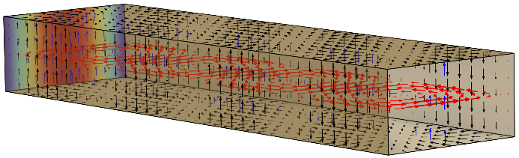

Fig.1. An example of the figure inserted into the text

The preferred format for figures is vector graphics. Otherwise, use a high resolution, at least 300 DPI.

## Tables

Tables (if necessary) should be included either as graphical or editable content. If possible, use a vector format and the same fonts and sizes as in the text. The tables must be placed in the center of the column. An example of a table is presented below.

Table 1: The parameters of the sensor



Acknowledgments can be inserted at the end of the article using type size 9 and Aptos italic: This work was partially supported by the XXX, country, under Grant No. 2024/XXX/YYY-ZZZ.

## References

References are cited in the text by square brackets [1]. Two or more references at the time may be put in one set of brackets [1, 2]. The references are numbered in the order in which they are cited. The references are written using type size 8 with Aptos font. The style of the references is as follows:

REFERENCES

[1] Johnson B., Pike G.E., Preparation of Papers for Transactions, *IEEE Trans. Magn*., 50 (2002), No. 5, 133-137  
doi: XXXXXXXX

[2] Lee P. J., Engineering superconductivity, *Wiley&Sons* 2001

**Authors**: First Author, University of XXX, address, e-mail, Second Author, University of XXX, address, e-mail, Third Author, University of XXX, address, e-mail